1. Out of Boundary Paths

Aim
To find the number of possible paths for a ball to move out of a given grid boundary within a specified number of moves.

Algorithm
- Read the number of rows m, columns n, maximum moves N, and starting position.
- From the current cell, consider four possible movements: up, down, left, and right.
- If the ball moves outside the grid, count that path.
- If the maximum number of moves is reached while the ball is inside, return 0.
- Otherwise, recursively calculate the number of paths for all four directions.
- Add the results and display the total number of paths.
- Use modulo 10^9 + 7 to keep the result within limits.

Procedure
- Open Python IDLE, VS Code, or an online Python compiler.
- Enter the program given below.
- Run the program.
- Enter the grid size, maximum number of moves, and starting position.
- The program calculates the number of paths that go outside the boundary.
- Observe and record the output.
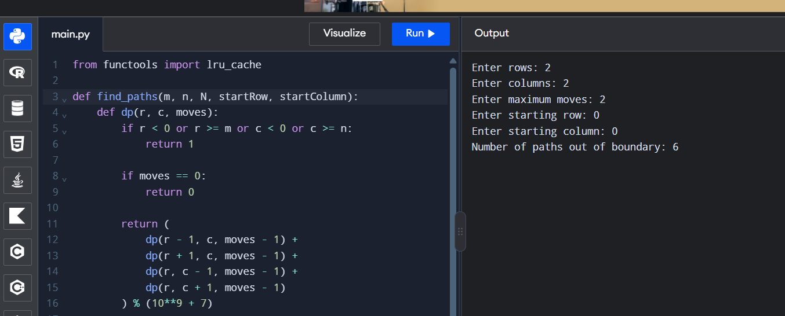

Result
Thus, the number of paths through which the ball moves out of the grid boundary was successfully calculated using Python.

